Lab # 2
JAVA OPERATORS and math class

OBJECTive
To Study Arithmetic Operators and math class.

THEORY

Arithmetic Operators
Arithmetic operators are used in mathematical expressions in the same way that they
are used in algebra. The following table lists the arithmetic operators:
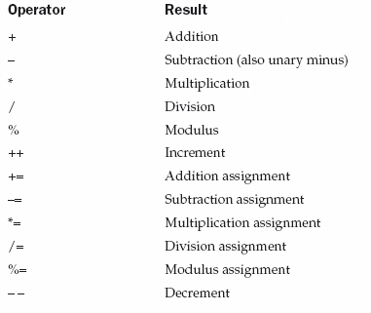

Arithmetic Assignment Operators

Java provides special operators that can be used to combine an arithmetic operation
with an assignment.

// Demonstrate several assignment operators.
public class OpEquals {
public static void main(String args[]) {
int a = 1;
int b = 2;
int c = 3;
a += 5;
b *= 4;
c += a * b;
c %= 6;
System.out.println("a = " + a);
System.out.println("b = " + b);
System.out.println("c = " + c);
}
}

Output
a = 6
b = 8
c = 3

Increment and Decrement

- The ++ and the – – are Java’s increment and decrement operators.
- ++ a and a ++ are pre and post increment and -- a and a-- are pre and post decrement
The following program demonstrates the increment operator.

// Demonstrate ++.
public class IncDec {
public static void main(String args[]) {
int a = 1;
int b = 2;
int c;
int d;
c = ++b;
d = a++;
c++;
System.out.println("a = " + a);
System.out.println("b = " + b);
System.out.println("c = " + c);
System.out.println("d = " + d);
}
}

Output
a = 2
b = 3
c = 4
d = 1

Math Classes
The Math class contains all the floating-point functions that are used for geometry and trigonometry, as well as several general-purpose methods. Math defines two double constants: E (approximately 2.72) and PI (approximately 3.14).

The Java Math library function Math.random() generates a double value in the range [0,1). Notice this range does not include the 1.

import java.lang.Math;
public class MathDemo
{
public static void main(String[] args)
{ double num = -4876.1874d;
double x=10.0,y=20.0;
int max=15;

// print absolute value of num
System.out.println("\nMath.abs(" + x + ")= " + Math.abs(num));

// print square root value of x
System.out.println("\nMath.sqrt(" + x + ")= " + Math.sqrt(x));

// print power value of x
System.out.println("\nMath.pow(" + x + ")= " + Math.pow(x,y));

// print exponential value of x
System.out.println("\nMath.exp(" + x + ")= " + Math.exp(x));

// print sine value of x in radian
System.out.println("\nMath.sin(" + x + ")= " + Math.sin(x));

// print maximum value
System.out.println("\nMath.max(" + x + ")= " + Math.max(x,y));

// print random value
System.out.println("\nMath.random()= " +(Math.random());
}
}
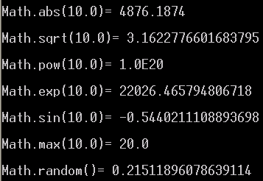
Output:

LAB TASK

- Write a program to implement calculator that can perform all function define above.
- Write a program to perform a calculation of quadratic formula, by using Math class.
- Write a program that take two inputs string arguments and add them as a integers.(use Integer.parseInt())

- Write a program that inputs a decimal integer and displays its value in hexadecimal.

- Write a program that can generates 100 random characters but prints only m Vowels.
- Write a program to convert given no. of days into months and days.
(Assume that each month is of 30 days)
Example :
Input – 69
Output - 69 days = 2 Month and 9 days.

